**Aim:** To understand various data types in R and working with different operators

**IDE:** R Studio

**Theory:**

In programming languages, we need to use various variables to store various information. Variables are the reserved memory location to store values. As we create a variable in our program, some space is reserved in memory.

In R, there are several data types such as integer, string, etc. The operating system allocates memory based on the data type of the variable and decides what can be stored in the reserved memory.

**Data types in R**

To make the best of the R language, you'll need a strong understanding of the basic data types and data structures and how to operate on those.

• character

• numeric (real or decimal)

• integer

• logical

• complex

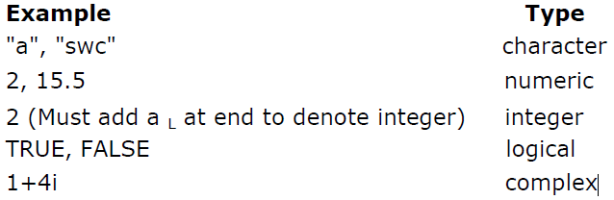

**Case Sensitivity**

Lastly, note that R is a case sensitive programming language. Meaning all variables, functions, and objects must be called by their exact spelling:

x <- 1

y <- 3

z <- 4

x * y * z ## [1] 12

x * Y * z

## Error in eval(expr, envir, enclos): object 'Y' not found

There are five operators in R:

1. Arithmetic Operators
2. Relational Operators
3. Logical Operators
4. Assignment Operators
5. Miscellaneous Operators
6. **Arithmetic Operators**

These operators perform basic arithmetic operations like addition, subtraction, multiplication, division, exponent, modulus, etc.

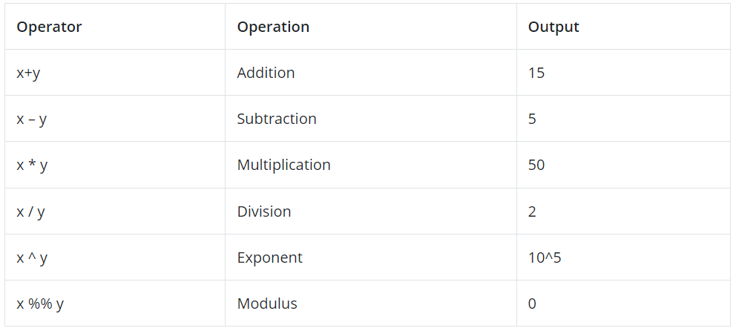

### Relational Operators

These operators are used to compare two values or variables. To find if one is smaller, greater, equal, not equal, and other similar operations these operators are used. A relational operator is always a Logical value, that is either TRUE or FALSE.

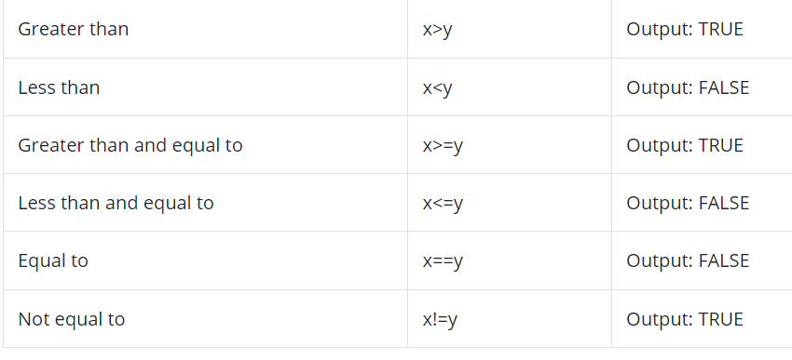

### ****Logical Operators****

These operators are used to perform Boolean operations like AND, OR, NOT, etc. on variables.  
Different logical operators are as follows:

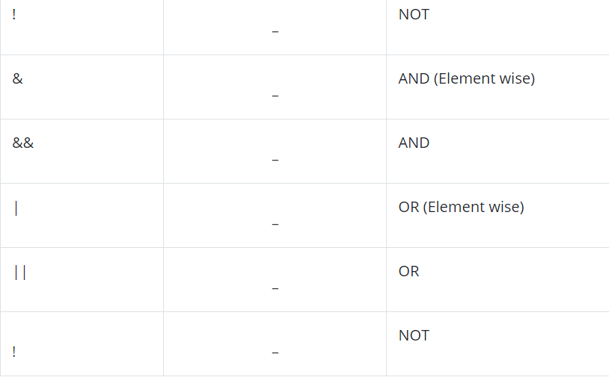

### ****Assignment Operators****

### The use of these operators is to assign values to the variables. There are two kinds of assignments, leftwards assignment, and rightwards assignment. Operators ‘<-‘ and  ‘=’ are used to assign values to any variable. x<- 3 or x = 3 (Leftwards Assignment) 3 -> x or x = 3 (Rightwards Assignment)

### ****Miscellaneous Operators****

These R programming operators are used for special cases and are not for general mathematical or logical computation. colon operator – It is used to generate a series of numbers in sequence for a vector.

**Programs:**

Write R script that demonstrates the functionality of all the operators of

1. Arithmetic Operators
2. Relational Operators
3. Logical Operators
4. Assignment Operators
5. Miscellaneous Operators

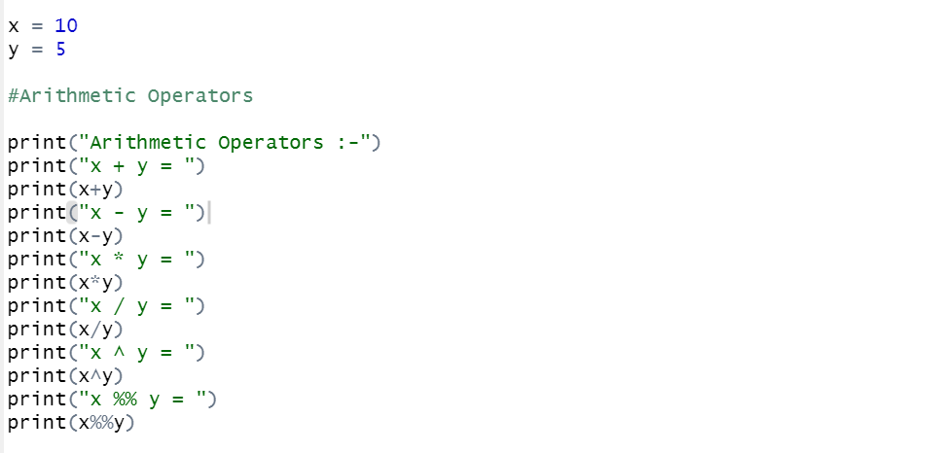

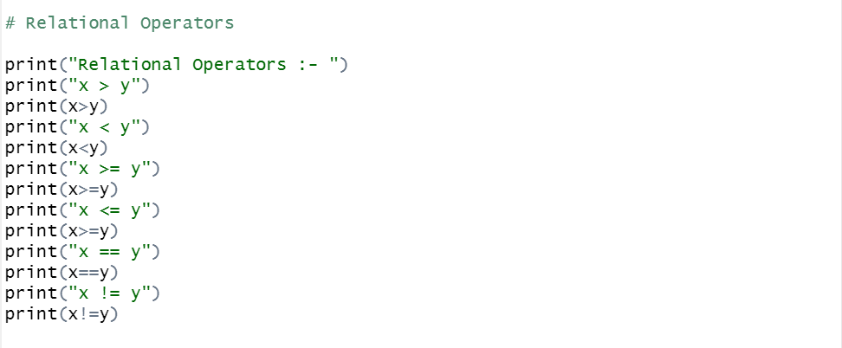

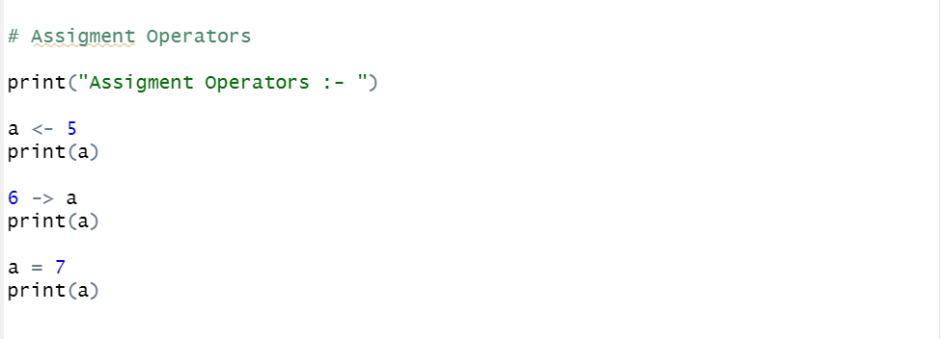

**Output:**

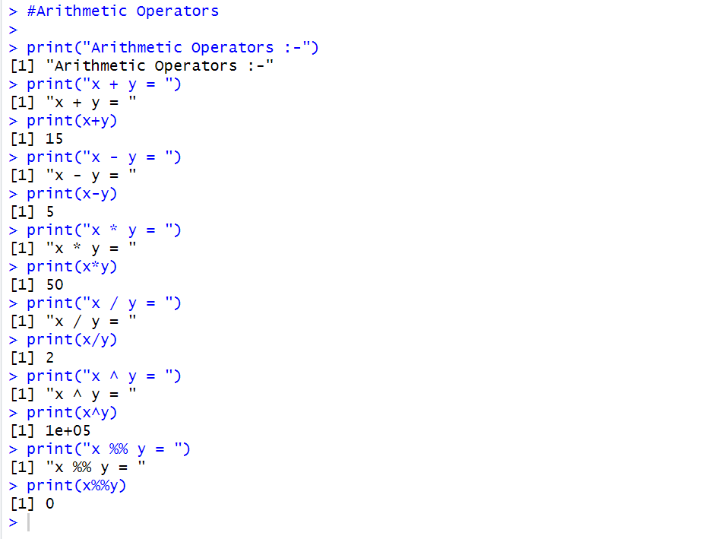

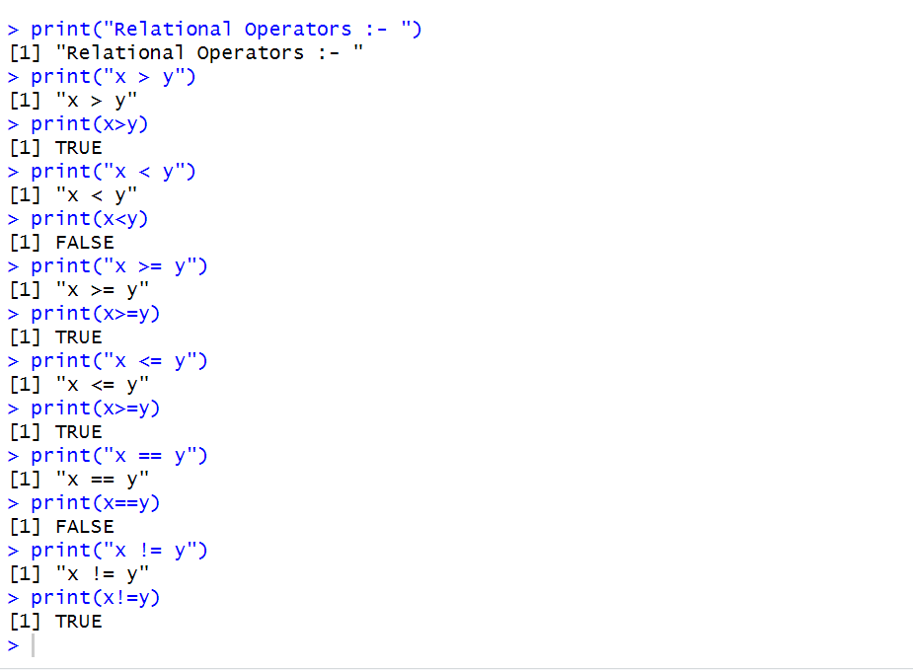

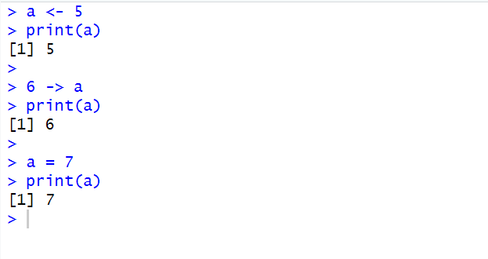

**Observation and Learnings:**

_________________________________________________________________________________________________________________________________________________________________________________________________________________________________________________________________________________________________________________________________________________________________________________________________